WEEK: 7
Applying the Auto Encoder algorithms for encoding the KDD datasets.

AIM: To write a python program to apply the auto encoder algorithms for encoding the real-world data.

Algorithm:
- Start the program.
- Import the necessary libraries and dataset.
- Build the model by using Auto encoder techniques.
- Define Encoder
- Define Decoder
- Compile and train the model.
- Visualize the original and reconstructed data.
- Stop the program.

Program:
import numpy as np
import tensorflow as tf
from tensorflow import keras
from tensorflow.keras import layers

latent_dim = 2

encoder_inputs = keras.Input(shape=(28, 28, 1))
x = layers.Conv2D(32, 3, activation="relu", strides=2, padding="same")(encoder_inputs)
x = layers.Conv2D(64, 3, activation="relu", strides=2, padding="same")(x)
x = layers.Flatten()(x)
x = layers.Dense(16, activation="relu")(x)
z_mean = layers.Dense(latent_dim, name="z_mean")(x)
z_log_var = layers.Dense(latent_dim, name="z_log_var")(x)
encoder = keras.Model(encoder_inputs, [z_mean, z_log_var], name="encoder")

latent_inputs = keras.Input(shape=(latent_dim,))
x = layers.Dense(7 * 7 * 64, activation="relu")(latent_inputs)
x = layers.Reshape((7, 7, 64))(x)
x = layers.Conv2DTranspose(64, 3, activation="relu", strides=2, padding="same")(x)
x = layers.Conv2DTranspose(32, 3, activation="relu", strides=2, padding="same")(x)
decoder_outputs = layers.Conv2DTranspose(1, 3, activation="sigmoid", padding="same")(x)
decoder = keras.Model(latent_inputs, decoder_outputs, name="decoder")

class VAE(keras.Model):
def __init__(self, encoder, decoder, **kwargs):
super(VAE, self).__init__(**kwargs)
self.encoder = encoder
self.decoder = decoder

def train_step(self, data):
if isinstance(data, tuple):
data = data[0]
with tf.GradientTape() as tape:
z_mean, z_log_var = self.encoder(data)
z = self.sampling((z_mean, z_log_var))
reconstruction = self.decoder(z)
reconstruction_loss = tf.reduce_mean(
keras.losses.binary_crossentropy(data, reconstruction)
)
reconstruction_loss *= 28 * 28
kl_loss = 1 + z_log_var - tf.square(z_mean) - tf.exp(z_log_var)
kl_loss = tf.reduce_mean(kl_loss)
kl_loss *= -0.5
total_loss = reconstruction_loss + kl_loss
grads = tape.gradient(total_loss, self.trainable_weights)
self.optimizer.apply_gradients(zip(grads, self.trainable_weights))
return {
"loss": total_loss,
"reconstruction_loss": reconstruction_loss,
"kl_loss": kl_loss,
}

def call(self, data):
z_mean, z_log_var = self.encoder(data)
z = self.sampling((z_mean, z_log_var))
return self.decoder(z)

def sampling(self, args):
z_mean, z_log_var = args
batch = tf.shape(z_mean)[0]
dim = tf.shape(z_mean)[1]
epsilon = tf.keras.backend.random_normal(shape=(batch, dim))
return z_mean + tf.exp(0.5 * z_log_var) * epsilon

# Normalize image data
(x_train, _), (x_test, _) = keras.datasets.mnist.load_data()
x_train = np.expand_dims(x_train, -1).astype("float32") / 255.0
x_test = np.expand_dims(x_test, -1).astype("float32") / 255.0

vae = VAE(encoder, decoder)
vae.compile(optimizer=keras.optimizers.Adam())

vae.fit(x_train, epochs=30, batch_size=128)

# Generate new images from the learned latent space
n = 10
digit_size = 28
figure = np.zeros((digit_size * n, digit_size * n))
# Sample random vectors from a normal distribution
z_sample = np.random.normal(size=(n * n, latent_dim))
# Decode the vectors into images
x_decoded = decoder.predict(z_sample)
# Reshape the images and combine them into a grid
for i in range(n):
for j in range(n):
digit = x_decoded[i * n + j].reshape(digit_size, digit_size)
figure[i * digit_size : (i + 1) * digit_size,
j * digit_size : (j + 1) * digit_size] = digit
# Plot the grid of images
plt.figure(figsize=(10, 10))
plt.imshow(figure, cmap="Greys_r")
plt.axis("off")
plt.show()

Output:
Epoch 1/30
469/469 ━━━━━━━━━━━━━━━━━━━━ 51s 103ms/step - kl_loss: 1.7715 - loss: 216.4252 - reconstruction_loss: 214.6537
Epoch 2/30
469/469 ━━━━━━━━━━━━━━━━━━━━ 50s 106ms/step - kl_loss: 2.6142 - loss: 187.6249 - reconstruction_loss: 185.0107
Epoch 3/30
469/469 ━━━━━━━━━━━━━━━━━━━━ 49s 105ms/step - kl_loss: 3.7130 - loss: 168.3136 - reconstruction_loss: 164.6006
Epoch 4/30
469/469 ━━━━━━━━━━━━━━━━━━━━ 82s 105ms/step - kl_loss: 3.7022 - loss: 162.6436 - reconstruction_loss: 158.9414
Epoch 5/30
469/469 ━━━━━━━━━━━━━━━━━━━━ 49s 105ms/step - kl_loss: 3.7691 - loss: 159.5112 - reconstruction_loss: 155.7421
Epoch 6/30
469/469 ━━━━━━━━━━━━━━━━━━━━ 49s 105ms/step - kl_loss: 3.7848 - loss: 157.4791 - reconstruction_loss: 153.6943
Epoch 7/30
469/469 ━━━━━━━━━━━━━━━━━━━━ 84s 110ms/step - kl_loss: 3.8073 - loss: 156.1183 - reconstruction_loss: 152.3111
Epoch 8/30
469/469 ━━━━━━━━━━━━━━━━━━━━ 80s 105ms/step - kl_loss: 3.8224 - loss: 154.9798 - reconstruction_loss: 151.1574
Epoch 9/30
469/469 ━━━━━━━━━━━━━━━━━━━━ 49s 104ms/step - kl_loss: 3.8423 - loss: 154.0616 - reconstruction_loss: 150.2193
Epoch 10/30
469/469 ━━━━━━━━━━━━━━━━━━━━ 49s 105ms/step - kl_loss: 3.8372 - loss: 153.3076 - reconstruction_loss: 149.4704
Epoch 11/30
469/469 ━━━━━━━━━━━━━━━━━━━━ 81s 104ms/step - kl_loss: 3.8385 - loss: 152.6945 - reconstruction_loss: 148.8560
Epoch 12/30
469/469 ━━━━━━━━━━━━━━━━━━━━ 82s 105ms/step - kl_loss: 3.8445 - loss: 152.1690 - reconstruction_loss: 148.3245
Epoch 13/30
469/469 ━━━━━━━━━━━━━━━━━━━━ 50s 106ms/step - kl_loss: 3.8330 - loss: 151.6062 - reconstruction_loss: 147.7732
Epoch 14/30
469/469 ━━━━━━━━━━━━━━━━━━━━ 81s 104ms/step - kl_loss: 3.8258 - loss: 151.2762 - reconstruction_loss: 147.4504
Epoch 15/30
469/469 ━━━━━━━━━━━━━━━━━━━━ 82s 105ms/step - kl_loss: 3.8282 - loss: 150.8740 - reconstruction_loss: 147.0458
Epoch 16/30
469/469 ━━━━━━━━━━━━━━━━━━━━ 49s 105ms/step - kl_loss: 3.8330 - loss: 150.6450 - reconstruction_loss: 146.8120
Epoch 17/30
469/469 ━━━━━━━━━━━━━━━━━━━━ 49s 104ms/step - kl_loss: 3.8186 - loss: 150.1966 - reconstruction_loss: 146.3781
Epoch 18/30
469/469 ━━━━━━━━━━━━━━━━━━━━ 49s 104ms/step - kl_loss: 3.8172 - loss: 149.9545 - reconstruction_loss: 146.1373
Epoch 19/30
469/469 ━━━━━━━━━━━━━━━━━━━━ 82s 104ms/step - kl_loss: 3.8122 - loss: 149.7054 - reconstruction_loss: 145.8932
Epoch 20/30
469/469 ━━━━━━━━━━━━━━━━━━━━ 82s 105ms/step - kl_loss: 3.8129 - loss: 149.4550 - reconstruction_loss: 145.6421
Epoch 21/30
469/469 ━━━━━━━━━━━━━━━━━━━━ 82s 104ms/step - kl_loss: 3.8093 - loss: 149.2683 - reconstruction_loss: 145.4590
Epoch 22/30
469/469 ━━━━━━━━━━━━━━━━━━━━ 82s 104ms/step - kl_loss: 3.8123 - loss: 148.9649 - reconstruction_loss: 145.1526
Epoch 23/30
469/469 ━━━━━━━━━━━━━━━━━━━━ 49s 104ms/step - kl_loss: 3.8074 - loss: 148.8769 - reconstruction_loss: 145.0695
Epoch 24/30
469/469 ━━━━━━━━━━━━━━━━━━━━ 49s 105ms/step - kl_loss: 3.8028 - loss: 148.6817 - reconstruction_loss: 144.8788
Epoch 25/30
469/469 ━━━━━━━━━━━━━━━━━━━━ 49s 103ms/step - kl_loss: 3.7998 - loss: 148.3736 - reconstruction_loss: 144.5738
Epoch 26/30
469/469 ━━━━━━━━━━━━━━━━━━━━ 48s 103ms/step - kl_loss: 3.7942 - loss: 148.3651 - reconstruction_loss: 144.5709
Epoch 27/30
469/469 ━━━━━━━━━━━━━━━━━━━━ 49s 103ms/step - kl_loss: 3.8058 - loss: 148.0445 - reconstruction_loss: 144.2387
Epoch 28/30
469/469 ━━━━━━━━━━━━━━━━━━━━ 82s 104ms/step - kl_loss: 3.8004 - loss: 147.9872 - reconstruction_loss: 144.1867
Epoch 29/30
469/469 ━━━━━━━━━━━━━━━━━━━━ 82s 103ms/step - kl_loss: 3.7980 - loss: 147.7369 - reconstruction_loss: 143.9389
Epoch 30/30
469/469 ━━━━━━━━━━━━━━━━━━━━ 82s 103ms/step - kl_loss: 3.8034 - loss: 147.6514 - reconstruction_loss: 143.8480
4/4 ━━━━━━━━━━━━━━━━━━━━ 0s 28ms/step
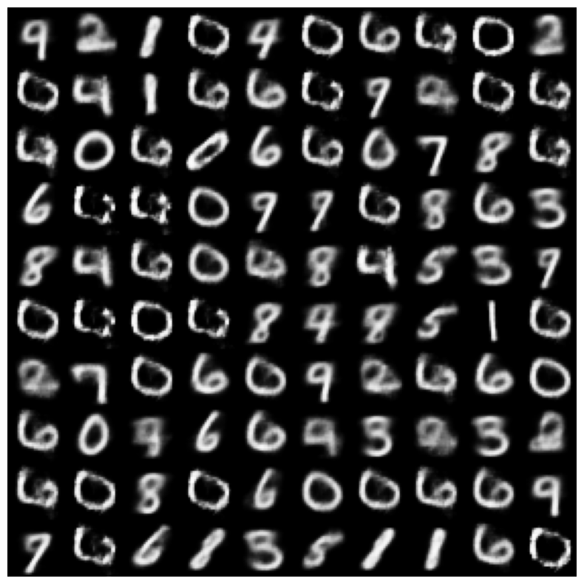

Result:
Thus, the autoencoder models on real-time dataset are applied in the field deep learning and the model was evaluated and predicted the results successfully.

